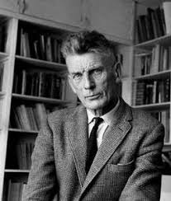
Absurd Theatre – Sam Beckett

- 20th century
- Questions the nature of reality and illusion
- Appears to be without meaning

Ideas:
- Explores what happens when human existence has no meaning or purpose
- Logical construction and argument gives way to irrational and illogical speech and silence
- Humans are controlled or menaced by invisible or outside forces

Characteristics:
- Broad comedy
- Vaudeville elements
- Absurd and tragic imagery together
- Characters in hopeless situations
- Forced to do repetitive or meaningless actions
- Dialogue full of clichés
- Wordplay
- Nonsense
- Cynical plots

Conventions:
- Time, place and identity are ambiguous or fluid, and even basic causality breaks down often
- Non realistic or surreal characters or situations
- Meaningless (or seemingly so) plots full of pointless chaos and elements of non realism
- Seemingly meaningful or artful use of chaos
- Human condition portrayed as absurd or meaningless or illogical
- Language, words and communication lose function and create misunderstandings between characters
- Minimal plot, minimal staging, babbling, abstract setting, arbitrary and illogical action

http://theatrestyles.blogspot.com/2014/12/the-theatre-od-absurd.html

