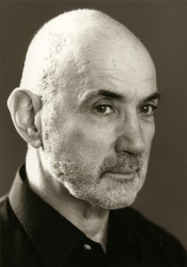
Actor Centered – Mike Alfreds

- Naturalism
- Stanislavskian feel
- Action, Reaction, and Decision
- Actors and their instincts
- Theatre as the art of acting

Clap Tag:
- Responding instinctively
- Improvisation of a scene
- Clap means freeze, and a second scenario is given to the pair of actors
- The less information given the more realistic they tend to be

Points of Concentration:
- Affects character, objective and scene
- Environmental point of concentration is something happening or that happened in the outside world that can affect you
- Individual point of concentration is about the character
- These make the actor think about how to play a scene

Applying:
- He and his actors create a complete infrastructure and framework
- Breaking down of texts into simple actions, and connecting actors back to it
- Character and motivation
- Work of the environment, space, relationships, style and the meaning of the play
- All this is embodied organically through long elaborate rehearsal process
- Truth in the moment

