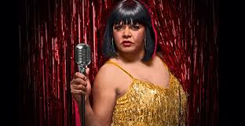
Blak Cabaret

- Satirical comedy
- Features Aboriginal and Torres Strait Islander performers
- Evolved from a showcase for individuals, to a full scale theatrical productions

The Storyline and Purpose:
The storyline involves “The Aboriginal invasion”. The show is supposed to be provocative with people’s feelings and make them laugh, cry, think and feel uncomfortable, but enlightened too. It’s a look into Australian history in a new way.

http://www.beat.com.au/arts/blak-cabaret

