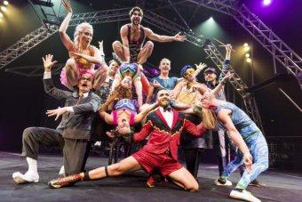
Circus Oz

- Benn around for over 40 years
- All human, all entertainment, all ages show
- Travels and performs internationally
- Australia’s national circus

The History:
- Born in 1978 in Melbourne, Australian College of Dramatic Arts
- Rock n Roll show
- All human circus
- Audiences of all ages
- The philosophies still exist today that the circus was created around; collective ownership and creation, gender equity and a uniquely Australian signature and team work
- Founded by 2 already successful groups, Soapbox Circus and New Circus (both Australian)

The Show:
- Breathtaking stunts
- Irreverent humour
- Brilliant live music
- Aims to promote the best of the Australian spirit; generosity, diversity, death defying bravery and a fair go for all
- Strong belief in tolerance, diversity and human kindness
- Often engages with social issues and is involved in charity work
- The show had to be contemporary and new
- Added rock n roll elements and popular theatre and satire
- They wanted it to be funny, irreverent and spectacular with many multi skilled individuals, rather than a few stars

https://www.circusoz.com/circus-oz/about-circus-oz.html

