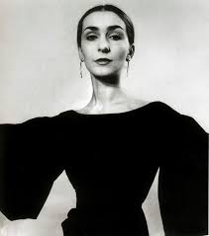
Dance Art – Pina Bausch

- Dancer and choreographer combined with theatre
- Mature style
- Absence of plot
- Revelation of characters

Style and Method:
- Hallmarks include absence of any sustainable plot or conventional senses of progression, or revelation of characters
- Pieces built on brief episodes of dialogue and action
- Often centered on a surreal situation, prop or costume
- Actions are multi layered
- Usually performed simultaneously
- Audience involvement is common
- Audience address
- Repetition is important as a structuring device
- Alienation and/or stopping of action are common to force one to consider what is presented again and again from new and/or different perspectives
- Use of ennui (a feeling of listlessness and dissatisfaction arising from a lack of occupation or excitement)
- It not conventional dance nor orthodox theatre as dialogue does not sustain drama
- Expression of feelings by whatever best conveys them
- Everyday movements to express personal experiences
- Role of the body is redefined and each dancer’s body tells its own story
- Choreography, stage, set, space, time, music, speech, costumes and personalities are all integral components to help communicate something that movements or words cannot do by themselves
- Many themes are recurrent (love and longing between man and woman, tensions, loneliness, alienation, inability to make human connections, rejection, self identity struggles, humour, tenderness, hope)
- Positive themes are less common and often overlooked
- She has often been labeled feminist but refuses social or political agenda of her works

https://prelectur.stanford.edu/lecturers/bausch/life.html#grow

