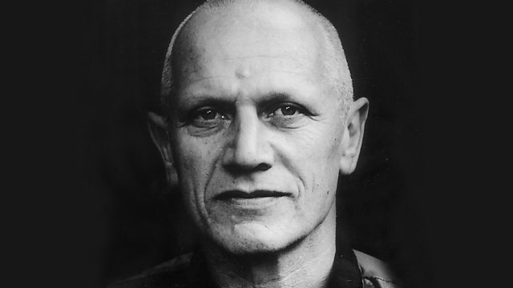
Expressionism Theatre – Steven Berkoff

- Exaggerated physical style
- Both popular and controversial
- Defying the ‘norms’ of naturalistic theatre
- Non-naturalism
- Total Theatre

Focus:
- Mime
- Exaggerated movement
- Dance
- Facial expressions
- Accents
- Monologue and dialogue
- Intra-dialogue
- Stage directions

Techniques:
- Background movement
- Repetitive actions
- Mime together with the spoken word
- Exploration of exchanging between 2 characters

Non-Naturalism:
- Movement over voice
- Only purpose of a script is to help minimalise and physicalise
- Stripping a story down to its most basic components
- Stemmed from Artaud and Theatre of Cruelty
- Every aspect of theatre must have purpose: lines perfectly learned, lighting effects to enhance audience experience, props for a use
- Create extreme moods to overwhelm, shock, amuse, scare or amaze an audience
- Minimalist with bare stage and little language
- Detach the audience from the play and make them think about the meaning

