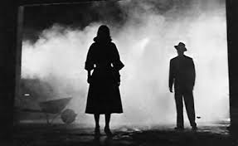
Film Noir

- Pessimism, fatalism and menace
- Dark style
- American crime dramas post WW2 era

Conventions:
- Cynical heroes
- Stark lighting effects
- Flashbacks
- Intricate plots
- Existentialist philosophy
- Femme fatale characters
- Male detective characters
- Low key lighting
- The dark undertones of these films represented the disenchantment with the times
- The Great Depression
- WW2
- Disillusionment of the American psyche

Lighting:
- High contrast, low key lighting
- Shadowy effect
- German expressionism
- Heightened the somber tones in the film genre
- Rain soaked streets
- Street lamps
- Shimmering halos
- Flashing neon signs in seedy bars or buildings
- Cigarette smoking lingering in and out of shadows

The Omniscient Narrator, Flashbacks and the Hero:
- There is a often a world weary, private eye, central character who narrates
- Subjective, jaded point of view
- Flashbacks are used to tell the tale that leads to tragedy
- Tension and suspense are created
- Impending doom
- Heroes often are morally ambiguous, fatalistic and alienated

https://www.britannica.com/art/film-noir

