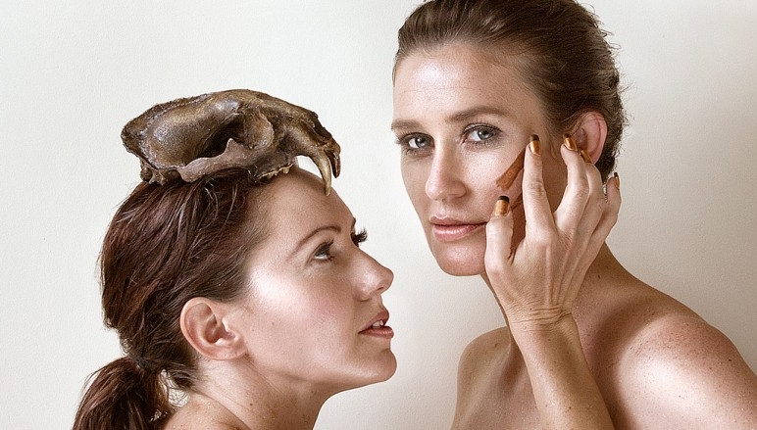
Human Animal Exchange

- Develops and presents new work through collaboration
- Focus on the relationship and struggle between our animal and human instincts with our place in the natural world

About the Company:
Human Animal Exchange develops and presents new work through collaborative practices. Primarily, they explore the relationship and struggle between our natural animal and human instincts with our place in the natural world. At the moment, there is experimentation with storytelling and pushing to extend into new theatrical modes. There is a certain power to good stories, and the company believes we are shaped by the stories we inherit.

Productions:
- They Saw a Thylacine
- Untold
- The Dust and Us
- A Donkey and a Parrot

Key Artists:
- Justine Campbell
- Sarah Hamilton

https://humananimalexchange.com/about-3/

