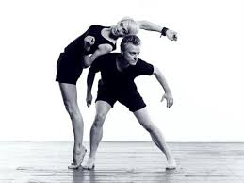
Kage

- Exists to explore and extend the form of dance
- Collaborates across cultures and disciplines to create works of skill, beauty and irreverence

The Vision:
- Explores and extends dance
- Cultures and disciplines combined
- Rich in ideas that resonate deeply with audiences
- Original contemporary dance works
- Diverse audiences
- Perspective that dance should play an inspiring, joyful and significant role in modern day life
- Forced to close due to funding cuts (a non for profit organisation)

http://www.kage.com.au

