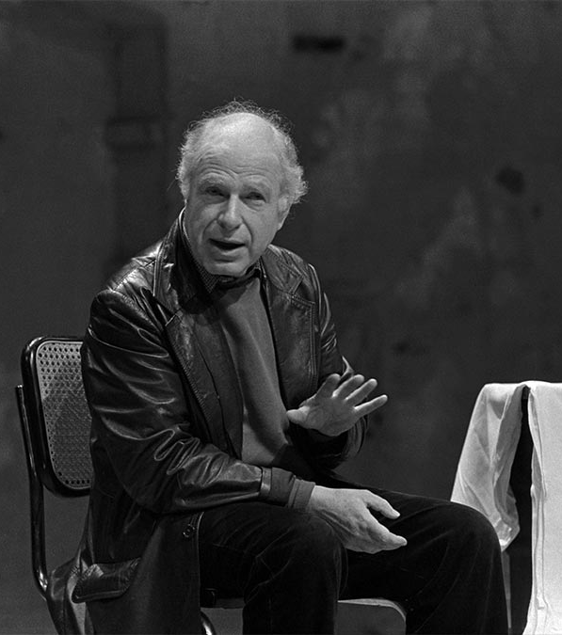
Living Theatre – Peter Brook
- Songs
- Drumming
- Dancing
- Ritualistic movement and chanting

~Certain symbols, e.g. pair of boots (always on the move) can change actors~

Symbols:
- Animals and birds can symbolize
- Puppets
- Human beings
- Stylised action
- Patterns of movement
- Freeze frame showing a key moment
- Repetitious movement
- Mask
- Gesture
- Music

