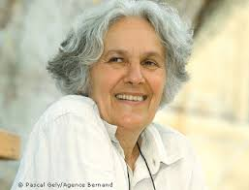
Physical Theatre – Ariane Mnouchkine

- Founded Paris avenue grade ensemble, Theatre de Soleil
- Theatre of the Sun
- Attempt at a universal style
- Collaborative art form

Hybrid Theatre Style:
- Hybrid theatre using aspects of physical theatre and her own processes
- Wanted to create theatre that moved beyond playwrights and directors
- Focus on collaboration without directors and so on
- Incorporated many styles from Ancient Greek to Commedia Del Arte to Asian rituals such as Kabuki and Kathakali and Chinese theatre traditions
- Highly physical and acrobatic
- Strong emotion by being in ‘the state’, by the actor depicting a central emotion that dominates physical and emotional life of a character before exploring changes

Space and Actor-Audience Relationship:
- Performers often worked in barns on gyms
- Mnouchkine did not like the confines of a regular stage
- She believed theatre cannot be restricted by the fourth wall
- The audience will often see the actors preparing makeup and costumes as they enter
- The stage is a sacred space
- The actor is the primary storyteller

