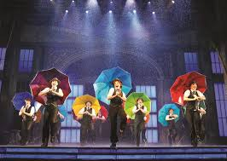
Zeal Theatre

- Stefo Nantsou
- Tom Lycos

The Company:
- Explores complex social issues
- Broad range of ethnically and culturally diverse audiences
- Blends live music, a rigorous physical theatrical style and uses the actor as a multi skilled storyteller

http://www.zealtheatre.com.au/

