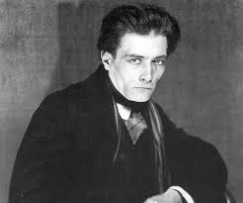
Theatre of Cruelty – Antonin Artaud

Both the world around him and the theatre itself needs change; surrealism

Movement and Gesture:
- Inspired by Balinese dancers
- Largely non verbal theatre
- Ritualistic
- Communication through ‘signs’ of facial expression and movement
- Style known as visual ‘poetry’

Stagecraft:
- Emphasis on lights and sounds
- Sound was loud, piercing and hypnotising
- The audience’s sense were assaulted (hence, ‘cruelty’)
- Lights were flooded or pinpointed
- Sets were eliminated
- Use of ancient clothing for rituals
- Over sized puppets or mannequins used
- Masks occasionally used

Acting and Characterisation:
- Actors encouraged to openly use emotions
- No emphasis on individual characters
- Less defined by movement

Actor-Audience Relationship:
- Intimate relationship created
- Actors performed around the audience in the center
- The audience was made to feel trapped by the actors physically surrounding them

Powerful Use of Ritual:
- Movement e.g. Balinese
- Dance
- Violent action/fighting
- Music (live)
- Chanting
- Singing

