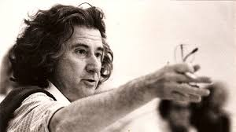
Theatre of the Oppressed – Augusto Boal

Theatre of the Oppressed: To help the suffering/recognise oppressions

What is?
What could be?

Image:
- Freeze frames: Pictures of … lives experience or feelings
- Sculpture: Individual or tableaux
- Invites the ‘spect-actors’ to create tableaux of frozen images to capture a moment in time dramatising an oppressive situation

Invisible:
- Creating ‘drama’ on the streets
- Masquerades as reality, performed in a public space
- Objective to unsettle passive social relations and spark critical dialogue amongst ‘spect-actors’ who never realise they are part of a play

Forum:
- Audience can participate
- Short play or scene dramatising a terribly oppressive situation that the ‘spect-actors’ cannot be happy with
- Situation is shown again and at any point, ‘spect-actors’ can yell “FREEZE!”, to step on stage and replace the protagonist to take the situation in a new direction
- Theatre thus becomes rehearsal for real life action

Rituals and Symbols:
- Rituals: Olympics – flame
- Symbols: …, logo, clenched fist, music

