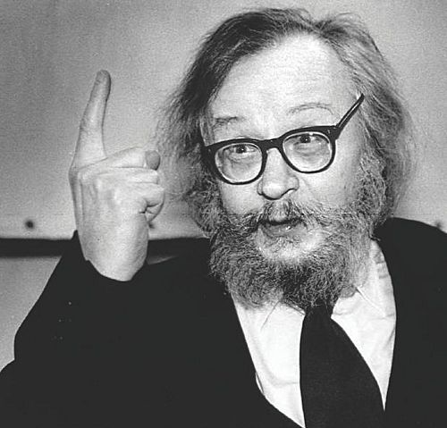
Theatre of the Poor – Jerzy Grotowski

Acting in the style relying on physical skill of the performer with heavy focus on object transformation used for symbols and significance

Movement and Gesture:
- Physical movement was a key component

Space and Actor-Audience Relationship:
- Traditional theatre spaces were ignored in preference for rooms and buildings
- Intense exploration of relationship between participant and spectator
- Aim was to eliminate division between actor and audience, creating a communion
- Spectators on many sides

Stagecraft:
- Acting area typically bare with few props and no set
- Object transformation was key, often symbolic and of great significance
- Lighting flooded with no use of spotlights or focus area
- If used at all, costumes were anonymous, not identifying character

Acting and Characterisation:
- The actor and his or her skill as at the core
- Sometimes no ‘real’ props used, but employed actors as props instead
- Actor training was long and intense
- Actors with ego had no place
- Aim was for authenticity akin to that of Stanislavski, but more physical
- Stanislavski’s ‘emotional memory’ was used

Scripts:
- Experimentation with classic works in contemporary settings

