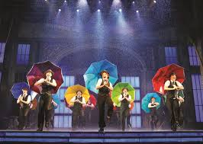
Musical Theatre

- Combines song, spoken dialogue, acting and dance
- Music, words, movement and technical aspects of entertainment as integrated

The Process:
- Script (Text), Scenario, Plan: The starting point (playwright)
- The Process: Creative efforts (director)
- The Product: The final work (cast)
- The Audience: Arts is a public display

Elements of Drama:
- Thoughts, Themes and Ideas: The meaning behind the performance
- The Plot or Action: The events of the play
- Characters: People presented in the perusing plot
- Language: Dialogue explicitly, or implicit body language
- Music: Encompassing rhythm, melody, composition and more, with delivery for the purpose of creating emotion or telling story
- Spectacle: Aspects of scenery, costumes, makeup, SFX, lights (and so on, the visuals)

http://homepage.smc.edu/adair-lynch_terrin/ta%205/elements.htm

