Prescribed Structure 8 – The Flower Thrower

Melbourne Protests:
- Veganism (pro)
- Animal Rights
- Climate Change
- My Body My Choice
- Preston’s Tallest Tree

Banksy’s Anti-Establishment Art:
- Kissing Coppers

- Napalm Girl

- Grim Reaper
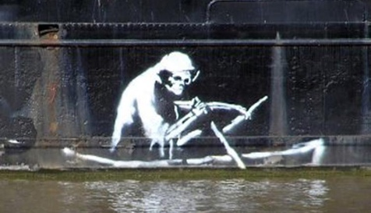

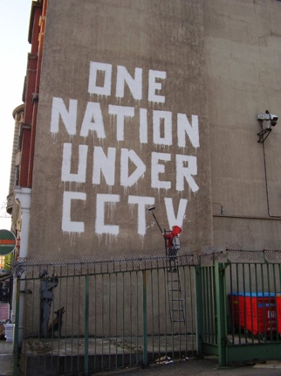
- OneNation CCTV

Banksy’s Key Ideas:
- Humour
- Sardonic wit
- Forces the audience to contemplate the underlying message
- Capitalism
- Advertising
- Politics
- Humanity
- Anti-establishment
- Anonymity
- NOT about commodification
- Art as political power

Political Artists:
- Yoko Ono
- Pablo Picasso
- Diego Rivera
- Banksy
- JR
- Shephard Fairy
- Max Ernst
- Peter Kien
- Norman Rockwell
- Dmitri Vrubel
- Ai Wei Wei
- Terry Richardson

